PART ONE

The Only Thing We Have to Fear

Chapter One

"The only thing we have to fear,
is fear itself." – Franklin D Roosevelt

We all know the feeling – that clutch of anxiety, boarding a plane. We remind ourselves that air travel is the safest mode of transportation; that driving to the airport is far more risky than flying. But we don't get scared behind the wheel, because we're the one in control. We know it's a false sense of security, yet we still feel safe.

We also know that our fear of flying is not entirely rational. But we feel it anyway, especially as we're herded through a wobbly skybridge to the door of the plane, where the crew greets us with reassuring smiles. And then, like millions of people, every day all over the world, we swallow our fear, smile back, and step over the threshold.

The risk / benefit calculations we make in situations like this, are shaped by the fact that the essential goods and services we've come to expect in modern life are rarely risk-free. So we take the best precautions we can, keep calm, and carry on.

Consider this:

- Since 1970, there have been over 80,000 deaths from commercial airline crashes. And yet the world's air traffic continues to increase, year after year.

- In 1975, the Banquiao Dam in China failed, causing an estimated 170,000 deaths, and the displacement of more than ten million people. The dam was rebuilt and safety measures were improved. Tens of millions of people have since repopulated the Banquiao flood plain, and renewable energy advocates have been pushing for a global expansion of hydroelectric power.

- In December 1984, an isocyanate gas leak from a pesticide plant in Bhopal, India injured more than 550,000 downwind residents, with more than 3,500 immediate deaths and 15,000 additional deaths in the following weeks. The company (Union Carbide) is still in business, and the same pesticides are still in use all over the world, including our own back yards.

- In September 2010, a natural gas pipe exploded in San Bruno, south of San Francisco. Fifty homes and eight lives were lost in the inferno. The pipeline was repaired, the neighborhood was rebuilt, the people moved back in, and California now uses more natural gas than it did in 2010.

Now consider the public reaction to these three incidents:

- In March 1979, a reactor at Three Mile Island in Pennsylvania suffered a partial meltdown, releasing a small amount of radioactive steam. The worst dose of radiation received by the public was equal to one half of one chest X-ray. But sensational media reports, and protests that linked nuclear power to nuclear weapons, stirred an understandably nervous public into outright panic. The only serious fallout from the event was that the nuclear power industry was nearly stopped in its tracks, and we expanded our use of coal.

- In April 1986, a Soviet reactor at the Chernobyl plant in Ukraine had a major meltdown, explosion and fire. With no containment structure, the fire raged for ten days, sending radioactive material thousands of miles downwind. Twenty-eight first responders died from radiation within the first four months after the accident, FN-2 along with fifteen children from thyroid cancer. FN-3 Twenty additional first responders died in the two decades since, though from undetermined causes. FN-4 Initial estimates of 4,000 long-term future casualties were based on a disputed "theory" called LNT (see Chapter Three), which has since been roundly discredited. FN-5. Yet some still believe, with no evidence, that the death toll was actually 1,000,000. It was also initially predicted that 50,000 people would die in the near term from cancer. Neither of those rumors proved to be true. But what did happen was this: more than 1,000,000 unwanted abortions, reluctantly chosen by mothers who feared having deformed and sickly children.FN 5.25Plus about 50,000 deaths from alcohol and depression. Multiple studies have shown that these consequences were triggered by nuclear fear, and the follow-on effects of that fear, along with the permanent and unnecessary relocation of over 300,000 people, many of whom suffered from the paralyzing fatalism that descends on people who are told they are incurable victims of something beyond their control. FN 5.5

FN-2: http://www.unscear.org/docs/reports/2008/11-80076_Report_2008_Annex_D.pdf (See page 8)
Tim sez:
There were 134 first responders who experienced Acute Radiation syndrome – ARS. Following 28 deaths in the immediate aftermath, twenty of them had died by year 2004 from various causes. Eighty-six first responders were then living. p. 58; Article 49, Fig VII
FN-3: https://www-pub.iaea.org/MTCD/publications/PDF/Pub1312_web.pdf (See pg.4)
FN-4: http://www.unscear.org/docs/reports/2008/11-80076_Report_2008_Annex_D.pdf
See Fig. VII "Outcome for Patients with ARS". Scale the light blue bar segments termed "later deaths".
FN-5: (http://www.unscear.org/docs/reports/2008/11-80076_Report_2008_Annex_D.pdf (See page 182, 183.)
FN 5.25 https://www.forbes.com/sites/michaelshellenberger/2019/06/11/top-ucla-doctor-denounces-depiction-of-radiation-in-hbos-chernobyl-as-wrong-and-dangerous/#3876f641e072 EXPLORE / COMPARE with https://www.vice.com/en_us/article/ywyqzv/why-hundreds-of-thousands-of-women-ended-their-pregnancies-after-chernobyl
FN-5.5: https://www.forbes.com/sites/jamesconca/2019/04/25/chernobyl-truth-drowns-in-dramatized-movie/#6415b0b5431d

- In March 2011, three reactors in Fukushima, Japan suffered partial meltdowns and hydrogen gas explosions. No one died from radiation, and UNSCEAR (United Nations Scientific Committee on the Effects of Atomic Radiation) has concluded that it is "highly unlikely" anyone will in the years ahead. But nuclear fear killed 1,600 Japanese citizens. Some died during the panicked and largely unnecessary evacuations, and others from subsequent stress-related deaths, triggered by long-term dislocation from their homes, land, and businesses. FN-6 Although 20,000 died from the earthquake and tsunami, it was nuclear fear that drove the news cycle, and still does.

FN-6: https://www.japantimes.co.jp/news/2014/02/20/national/post-quake-illnesses-kill-more-in-fukushima-than-2011-disaster#.XEEzSPx7nMW
https://ourworldindata.org/what-was-the-death-toll-from-chernobyl-and-fukushima

In a cohort of 1,700 evacuees from municipalities closest to the Fukushima plant, only ten people recieved more than 10 mSv, FN-7 the equivalent of one CT scan. FN-8 Even so, rumors of a fire in one of the reactors' spent fuel holding pools prompted the Japanese government to order a much wider evacuation than they originally called for. FN-9

FN-7:http://www.world-nuclear.org/information-library/safety-and-security/safety-of-plants/appendices/fukushima-radiation-exposure.aspx See the section "Radiation Effects", first para.)
FN-8:https://www.radiologyinfo.org/en/pdf/safety-xray.pdf See p. 2
FN-9:https://archive.nytimes.com/www.nytimes.com/interactive/2011/03/16/world/asia/japan-nuclear-evaculation-zone.html? Note the panicked wording on the graphic. The article was published less than a week after the accident.

The unfounded rumor was given credence by none other than Greg Jaczko, the anti-nuclear head of the NRC (the US Nuclear Regulatory Commission) at the time, who had sent an advisory team to Japan. Mr. Jaczko's hand-waving about a fire that never happened was directly responsible for the unnecessary dislocation of tens of thousands of people. His nuclear fear then carried over in his testimony to the US Congress, as he reported on the unfolding situation. The performance, duly recorded on C-SPAN, went viral. FN
https://www.forbes.com/sites/michaelshellenberger/2019/01/22/former-u-s-nuclear-safety-regulator-withheld-vital-aid-during-fukushima-crisis-says-top-official/#54b997141d52 (See second to last paragraph of article. After his stint at the NRC, he left government to start a for-profit wind consultant company)
https://www.dropbox.com/s/23ulwm5kmlpcinh/NRC_letter_about_Jaczko_13-X-2011.png?fbclid=IwAR0qbPwUw3qxU-RvZpI21Xu1jZTsXce3ff3PwjxELBZlJbwOqzS1l_EApec

So now everyone's worried about spent fuel pools catching fire, even though the chances of that happening in a meltdown are vanishingly small. In truth, a fuel pool fire only becomes a possibility if the backup generators can't replenish the water that may have sloshed out during an earthquake. The real issue at Fukushima was the glaringly obvious (and easily remedied) blunder of placing their backup generators in a basement on the beach, despite clear warnings from our own NRC at the time (1970s-80s). And sure enough, the generators were drowned by the tsunami of 2011, resulting in three meltdowns. As it turns out, the 9.1 quake was not the proximate cause of the meltdowns. In fact, every reactor in Japan, including the ones at Fukushima, survived the earthquake just fine.

Fukushima was due to human error, not nuclear technology. The best car ever built will fail without a cooling system. This is one of many reasons why a principal aim of advanced nuclear technology is to make reactors "Homer-proof". (See Part Three.)

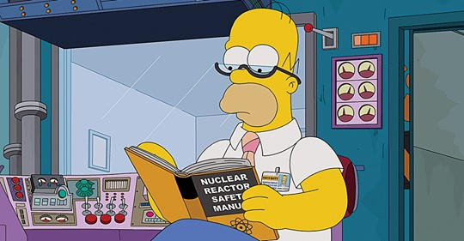

Jaczko's fear-mongering was so effective that even now, nearly a decade later, most of the evacuees still won't move back. This is in spite of encouragement by their own government, who originally ordered them to flee.

The official evacuation radius was 20 miles, but in light of the non-existent fire Jaszko recommended a 50-mile radius for any US citizens in the area. In the midst of an overwhelming emergency, the Japanese government deferred to his purported expertise, and imposed his recommendation on their own population.

This was in spite of the fact that Jaczko had no education or training in either radiation biology or reactor engineering. By kowtowing to the head of the NRC, the Japanese government's authority on nuclear matters was diminished in the eyes of its citizens, a distrust which continues to this day. FN
https://www.csmonitor.com/World/Asia-Pacific/2018/0221/Japan-wants-Fukushima-evacuees-to-go-home.-They-re-not-so-sure

https://www.washingtonpost.com/world/asia_pacific/eight-years-after-fukushimas-meltdown-the-land-is-recovering-but-public-trust-has-not/2019/02/19/0bb29756-255d-11e9-b5b4-1d18dfb7b084_story.html?fbclid=IwAR2-ORz0oUJNpk8cDeDTmx5OSDSfirB9AUu_8eJQA32eTTMog79Wtb24qWo&utm_term=.749b2ae615eb

Triggered by nuclear fear, the misplaced panic in Japan (and much of the world) has ballooned clean-up and relocation costs to an outlandish degree. Much like Chernobyl a quarter-century before, the fear of radiation and contamination has magnified the social and psychological consequences of an already-disastrous earthquake and tsunami. If everyone downwind had just taken the usual recommended precautions for fallout (remain indoors for a few days, tape up any openings, and filter your water), no one in the Fukushima evacuation zone would have received a dose of more than 100 mSv/year. FN-10

http://www.world-nuclear.org/information-library/safety-and-security/safety-of-plants/appendices/fukushima-radiation-exposure.aspx

“No harmful health effects were found in 195,345 residents living in the vicinity of the plant who were screened by the end of May 2011. All the 1,080 children tested for thyroid gland exposure showed results within safe limits, according to the report submitted to IAEA in June. By December, government health checks of some 1700 residents who were evacuated from three municipalities showed that two-thirds received an external radiation dose within the normal international limit of 1 mSv, 98% were below 5 mSv/yr, and ten people were exposed to more than 10 mSv. “

https://www.pnas.org/content/111/10/E914
“ . . . measurements were taken of the full-body contamination from caesium exposure of 9498 residents who had returned to the town and stayed there between September 2011 and March 2012. The study found that two-thirds of the residents had no detectable levels of caesium. Of the rest, only one appeared to have received an equivalent dose more than 1 mSv, and that was 1.07 mSv. The current ambient dose rate in the town is about 3 mSv/yr from external sources, well within the government's 20 mSv/yr limit for returnees.“

We'll explain mSv, or "milliSieverts", later, but just a hint for now: While the average yearly background dose on Earth is about 3 mSv, the scientific literature shows that an extra 100 mSv per year – even if it's received all at once – is not a cause for alarm. FN 10.5 And certainly not a cause for wholesale evacuation, or removing millions of tonnes of topsoil. Nevertheless, the Japanese government initially set the re-population threshold at a scrupulously low 20 mSv/year. FN-11
FN 10.5 https://www.rerf.or.jp/en/programs/research_activities_e/outline_e/proglss-en/

FN https://www.channelnewsasia.com/news/cnainsider/fukushima-daiichi-nuclear-radiation-residents-return-safety-9888552

This overwrought caution, fives times more stringent than the best scientfic evidence warrants, has been playing out non-stop for nearly ten years now, regardless of the fact that there are several heavily-populated areas around the world with much higher natural background levels. And these areas all have normal, and in some cases below normal, rates of cancer. FN-12
https://bravenewclimate.com/2015/01/24/what-can-we-learn-from-kerala/

You may have heard that the Japanese health and welfare ministry awarded compensation to the family of a first responder who died of lung cancer. FN-13 The claim was paid even though the responder recieved a cumulative dose of just 74 mSv in the days following the accident.FN-14 And, in spite of the fact that lung cancer takes decades to manifest (he was a smoker.)

FN-13:https://www.forbes.com/sites/jamesconca/2018/09/06/no-the-cancer-death-was-probably-not-from-fukushima/#15a33e2c21b5
FN-14: https://www.nytimes.com/2018/09/05/world/asia/japan-fukushima-radiation-cancer-death.html
https://www.forbes.com/sites/michaelshellenberger/2018/09/06/top-scientist-says-japans-decision-to-financially-reward-fukushima-worker-is-not-based-on-science/?fbclid=IwAR3-QBwcKIO31Kv3pqB3d-CF5dfERFcAHqcNv9nsfihpBvyXGeQqHOlr934#55b24db6a55a

You may have also heard that higher rates of thyroid cancer were found post-Fukushima. But that's because they tested every downwind child. Usually, doctors only test if symptoms are present, since most thyroid cancers are asymptomatic and benign.

If it's worth treating, it'll announce itself. And when it does, it's easily treated. So as a rule of thumb, tests are ony done if symptoms are present. This is why testing every child showed an apparent increase in cases. The same apparent discrepancy showed up in post-Chernobyl thyroid cases.FN 14.35. And both times, it was used as a phoney talking point by the anti-nuclear crowd.

FN-14.35: https://www.who.int/ionizing_radiation/chernobyl/backgrounder/en/
"Health Effects of the Chernobyl Accident: An Overview" 2006 World Health Organization. See section: "Doses received from the Chernobyl accident" sub-section "Thyroid Cancer".

"Who? Who? Who let the dogs out?" – Baha Men
(needs a better title)

The incidents at Fukushima and Three Mile Island killed no one, and no one will ever build a reactor like Chernobyl again. And yet, people are afraid of nuclear power. As green journalist George Monbiot wrote in the days after Fukushima:

"While nuclear causes calamities when it goes wrong, coal causes
calamities when it goes right, and coal goes right a lot more often
than nuclear goes wrong." FN
https://www.theguardian.com/environment/georgemonbiot/2011/mar/16/japan-nuclear-crisis-atomic-energy

That doesn't seem to matter to some people. It should. Because the actual harm caused by the production of nuclear power is nearly nonexistent.

After sixty years, with nearly one hundred reactors in operation, and hundreds more at sea, there have been a total of eight deaths related to nuclear power in the United States: three technicians from a partial meltdown of an experimental reactor at Idaho National Laboratory (1961) FN, and five construction and inspection deaths at other sites, none of which were caused by radiation.
https://en.wikipedia.org/wiki/SL-1?fbclid=IwAR3EiId2jMuRknJp7GhnPHsFNM9qiDkIQTkMSSFrZ3sDO8T9JFRBLYB869w

After generating about 27 trillion kilowatt-hours of carbon-free electricity, FN 14.5 not a single consumer has been injured or killed by the production of American nuclear power, or by "spent" fuel. (It's actually used fuel, since it is nowhere near being spent, and can be used again in the right reactors. See Part Three.)

FN14.5:https://world-nuclear.org/getmedia/b392d1cd-f7d2-4d54-9355-9a65f71a3419/performance-report.pdf.aspx See section 2.1 Global Highlights, page 10 figure 1

Tim sez:
With a careful scaling of the "Nuclear Electricity Production" bar graph, the purple segments for North America show that total historical US and Canadian nuclear electric production is about 30,000 TWh, 30 trillion kWh. Also see:

http://www.world-nuclear.org/information-library/country-profiles/countries-a-f/canada-nuclear-power.aspx
Working with the historical Canada reactor chart and other data in this link indicates that total historical Canadian nuclear electic production is about 3.3 trillion kWh.

Therefore, US historical total is about 27 trillion kWh (2,700,000 megawatt-hours or 2,700 terawatt-hours.)
(END FN 14.5)

Believe it or not, an American adult actually has a greater statistical chance of being shot by their own dog.FN-15

FN-15: https://www.washingtonpost.com/news/wonk/wp/2015/10/27/a-dog-shoots-a-person-almost-every-year-in-america/?utm_term=.ecd655fa1dfc

A word about mining (needs a better title)

There were some casualties in the early days of American uranium mining and milling. But the cancers and mortalities were traced to breathing mining dust and radon gas, both of which are present in any mine, rather than being in close contact with raw uranium.
(EXPLORE report on mining health
https://www.atsdr.cdc.gov/HAC/pha/MonticelloMillTailings/MonticelloMillTailingsPHAFinalBlue02262014_508.pdf

With proper respirators, the casualty rates have dropped to the same levels commonly found in other metal mining operations. The last uranium mining death in the US occured in 2010, in a non-nuclear jobsite accident.

Canada actually has more uranium mining than we do, and a major study shows that the health of their miners are on par with those in the US. FNMortality (1950-1999) an#6A52BF Another Canadian study shows that the CO₂ released in uranium mining and milling operations amounts to just 1.1 grams per kilowatt-hour of electricity produced from the isolated uranium fuel. The rest of the carbon dioxide from nuclear power, shown in the graph below, is from constructing the power plant.
FN https://www.ncbi.nlm.nih.gov/pubmed/27471915

Graphic on carbon fuel use in nuclear:
https://group.vattenfall.com/uk/siteassets/blocks/life_cycle_assessment_2018.pdf See s

ec 3.1, Figure 4

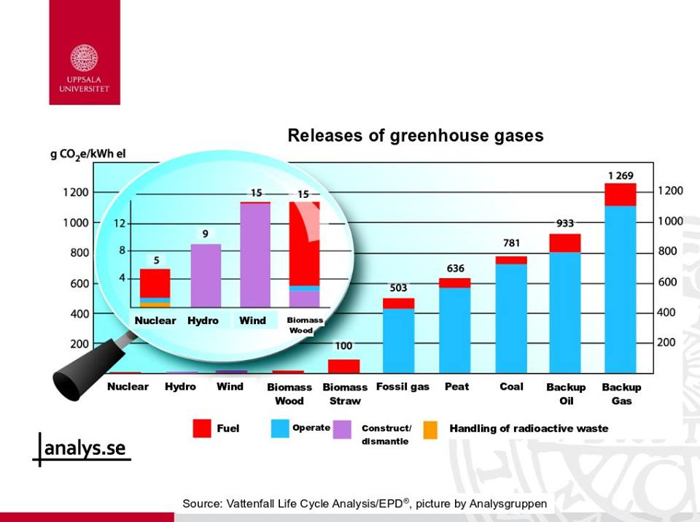
Nowadays, very few American uranium miners even go underground. This is mostly due to automation, as well as the fact that over half of domestic uranium is now extracted by environmentally benign in-situ leaching (ISL): injecting water underground that's been enhanced with oxygen bubbles or sodium bicarbonate (depending on geologic conditions), and drawing up the dissolved uranium. About 25% of our uranium ore is mined by open pit, and the rest by traditional deep-shaft methods. (PIE CHART)
(EXPLORE https://www.world-nuclear.org/information-library/nuclear-fuel-cycle/mining-of-uranium/uranium-mining-overview.aspx

Criticism has been raised about the environmental impacts of uranium waste ore and tailings. While the carbon footprint of mining and milling this ore is actually quite small, the sheer volume of displaced material is not. This is a larger environmental concern that's often ignored, even by nuclear advocates.

(Trigger warning: NUMBERS!)

With an average concentration in US uranium ore of just 3 ppm, about 300,000 tonnes of rubble and tailings (gravel and sand) remain from the extraction of one tonne of natural uranium, which must then be enriched.
FN 16.3 https://www.ncbi.nlm.nih.gov/pubmed/27471915

U extraction from phosphate, copper, etc. mining waste
https://www.iaea.org/newscenter/news/iaea-project-connects-dots-between-unconventional-uranium-extraction-and-high-temperature-nuclear-power-reactors

Natural uranium contains just 0.7% uranium-235. To use it as reactor fuel, the U-235 content has to be enriched to about 3.5%, or five times the concentration found in nature.

So five tonnes of uranium "yellowcake" (obtained from 1.5 million tonnes of raw ore) must be put through an enrichment process, to obtain one tonne of 3.5% LEU (low-enriched uranium) reactor fuel. (5 X 300,000 tonnes = 1.5 million tonnes).

A large 1,000 MWe (megawatts-electric) reactor burns through about 50 tonnes of LEU every year. This low-enriched fuel is made from around 250 tonnes of yellowcake, resulting in 75 million tonnes of mining waste per Gigawatt-year. ([50 tonnes LEU X 5 tonnes yellowcake] ÷ 1 tonne LEU = 250 tonnes yellowcake).

DRAW THE ABOVE, WITH THE MATH UNDER THE DRAWINGS

Most of the rubble and tailings come from open-pit mining, which has 45X the waste volume of traditional underground mining. FN 16.1 So if our domestic uranium mining continues with no change in methods, powering the entire nation with nuclear energy will more than double the yearly total for all US mining waste, which is currently about 1.6 billion metric tonnes.FN 16.2
FN 16.1: https://www.epa.gov/radiation/tenorm-uranium-mining-residuals
https://geoinfo.nmt.edu/resources/uranium/mining.html
FN 16.2 https://www.fhwa.dot.gov/publications/research/infrastructure/structures/97148/mwst1.cfm

TIM: we should footnote the math for the above discussion

Digging up this much dirt is obviously disruptive to the environment. Such wholesale displacement is not a clean-energy solution for the long term. But not to worry: Like most issues with nuclear power, this one can be solved with existing technology. In fact, our uranium mining can be reduced to virtually zero, even as we expand our reactor fleet, by using three proven and sustainable technologies:

- Recycle our used fuel and depleted uranium in fast-neutron reactors.

- Breed new fuel from fertile feedstocks of thorium and natural uranium.

- Extract natural uanium directly from seawater.

We'll explore the details in Part Three. Once these methods come into widespread use (hopefully in a few decades), we won't have much further need to mine any uranium at all.

For example, the depleted uranium mentioned in the first bullet point will power the nation, at our current rate of electrical consumption, for more than 1,000 years. FN 22.5 And the mining has already been done. Our current stockpile of used fuel, if "burned" in the right reactors, will give us another 177 years of power – by producing thirty times the energy we originally got from it. FN 22.6

The sooner we build the fast-neutron reactors that can use this "waste", the sooner we can stop mining uranium altogether. It's not waste; it's a valuable clean-energy resource. And the mining has already been done.

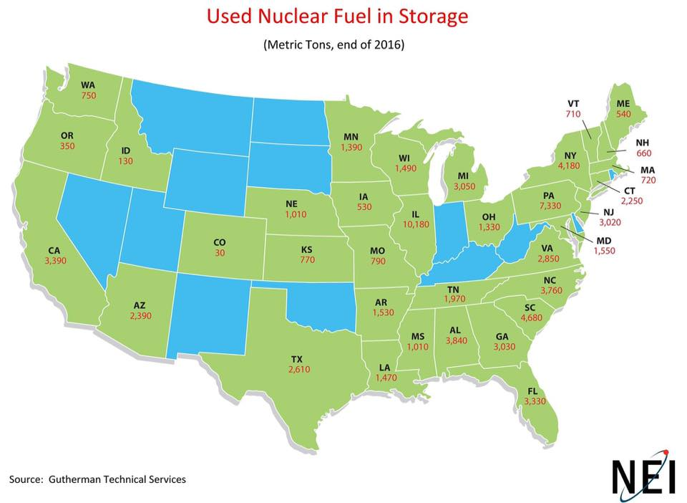

FN 22.5:

TIM; THIS IS ED'S CALCS FOR TOTAL USED FUEL, INCLUDING NAVY (from one of his facebook posts) (lightly edited) SEE ALSO AN ADDITIONAL POST BY ED ON NEXT PAGE)

‪The US is getting close to or over 1,000,000 tonnes of already mined, and stored fuel, as SNF (83,000 tonnes) & DU >>830,000 tonnes.‬ ‪That is 1,000,000 GWe-years, or 1 PWe-years‬
‪
Given:1 GWe-yr/tonne of actinide
I think it is way over 1,000,000 tonnes because of all the DU from weapons and Navy HEU enrichment.

Re: Navy spent fuel vs civilian: The main difference is that there is far, far more DU from HEU than from LALEU. But, what you should be able to get is the amount of stored DU and not need the HEU number or how many tonnes of DU per tonne of HEU. They also used two different high enrichment levels, so different amounts of DU per tonne. The closer you get to 100% enrichment the higher the DU/tonne of HEU.

Wiki says 686,500 tonnes by 2008, (all the Navy and weapons stuff was enriched before 2008) at 8-10 tonnesDU/tonne of SNF and the US accumulating 2,000 tonnes/year, and 11 years, 2000x8x11=176,000-220,000 tonnes DU or 862,500-906,500tinnes of DU, plus the 83,000 tonnes of SNF is 945,500-989,500 tonnes of fast reactor fuel gaining at 18,000-22,000 t/yr or 20TWe-hr/year additional energy storage. That kinda puts batteries to shame.

I forgot that the US used downblended Soviet HEU weapons gave us a jump in SNF from the MegaTonnes to MegaWatts program, for which we have no DU for about 20 years and 30-50% of reactor fuel. So, that is why we are not quite over 1,000,000 tonnes of Stored Nuclear Fuel. There is also a little bit of DU reprocessed from the Plutonium weapons residual fuel. The U was always extracted to get at the Plutonium, and ended up depleted, but also with other uranium isotopes and Np in it.

http://www.world-nuclear.org/information-library/current-and-future-generation/nuclear-power-in-the-world-today.aspx Scale the vertical axis. 6.6 cm represents 3000 TWh. Scale factor = 455 TWh /cm.

Global nuclear production in 2017 was 2506 TWh. Scale the purple segment for North America in the above link: 2.1 cm. 2.1 cm x 455 TWh /cm = 956 TWh in N. America. So N.A. accounted for 38% of world nuclear production in 2017. [956 ÷ 2506 = 0.38]

That percentage appears to hold steady back to year 2000. Smaller global production, but proportional share holds fairly steady back to year 1990.

Out of North America’s 38%, assign about 33% to USA. That is, One-third of world total. So 1.6 Mt /3 = 0.53 megatonnes DU in USA. Or 530,000 tonnes DU.

1 GWelec-yr / 1 tonne DU x 530,000 tonnes DU = 530,000 GWelec-yr of total energy from USA’s DU stockpile.

1 GWe-yr x 8760 h /yr = 8.76 TWh per 1 GW-yr

530,000 GW-yr of total energy x 8.76 TWh /1 GW-yr = 4.64e6 TWh of total energy from USA’s DU stockpile. (4.64 million TWh) (END OF ED's POST)

Tim sez:
Assume 1 tonne U-238 in fast-neutron LWR yields 1 GW-yr.

http://www.world-nuclear.org/information-library/nuclear-fuel-cycle/uranium-resources/uranium-and-depleted-uranium.aspx Section Depleted Uranium, 2nd paragraph. Depleted Uranium (DU) world stockpiles in storage = 1.6 megatonnes

https://www.eia.gov/tools/faqs/faq.php?id=427&t=3
First sentence:US electricity in 2018 = 4178 TWh /yr.

Therefore: 4.64e6 TWh of total DU energy divided by 4178 TWh /yr = 1100 years of US electricity supplied by our depleted uranium.

So we could run our US electric grid with DU for 1100 years at present consumption rate.
[end]

FN 22.6
https://www.nwtrb.gov/docs/default-source/reports/nwtrb-mngmntanddisposal-dec2017-508a.pdf?sfvrsn=12 See page 2, Figure ES-2.
Tim sez:
Cumulative SNF was 72,000 tonnes in 2017, and is going up at a rate of about 2,500 tonnes a year. Round that up to the generally accepted value of 80,000 tonnes SNF in the US in 2019. At a burn rate of about 1.05 GW-years / tonne, that comes to about 84,000 GW-y. Multiply by 8.76 TWh per GW-y for about 740,000 TWh available from SNF. Divide by 4178 TWh /yr for 177 years of operation from SNF.[end]

TIM: This is from a facebook post by ED: (Re: Navy spent fuel vs civilian):

The main difference is that there is far, far more DU from HEU than from LALEU. But, what you should be able to get is the amount of stored DU and not need the HEU number or how many tonnes of DU per tonne of HEU. They also used two different high enrichment levels, so different amounts of DU per tonne. The closer you get to 100% enrichment the higher the DU/tonne of HEU.

Wiki says 686,500 tonnes by 2008, (all the Navy and weapons stuff was enriched before 2008) at 8-10 tonnesDU/tonne of SNF and the US accumulating 2,000 tonnes/year, and 11 years, 2000x8x11=176,000-220,000 tonnes DU or 862,500-906,500tinnes of DU, plus the 83,000 tonnes of SNF is 945,500-989,500 tonnes of fast reactor fuel gaining at 18,000-22,000 t/yr or 20TWe-hr/year additional energy storage. That kinda puts batteries to shame.

I forgot that the US used downblended Soviet HEU weapons gave us a jump in SNF from the MegaTonnes to MegaWatts program, for which we have no DU for about 20 years and 30-50% of reactor fuel. So, that is why we are not quite over 1,000,000 tonnes of Stored Nuclear Fuel. There is also a little bit of DU reprocessed from the Plutonium weapons residual fuel. The U was always extracted to get at the Plutonium, and ended up depleted, but also with other uranium isotopes and Np in it.

And when we finally run out of all that, consider this:

The world's oceans hold about 4.5 billion tonnes of dissolved uranium oxide, continuously replenished by a natural process called steady-state leaching:

"The uranium in seawater is controlled by steady-state chemical reactions between the water and rocks that contain uranium, such that whenever uranium is extracted from seawater, the same amount is leached from the rocks to replace it." FN 22.75 https://cna.ca/news/theres-uranium-seawater-renewable/
Source paper -- http://large.stanford.edu/courses/2011/ph241/chan1/

This means that at any one moment in time, the world's oceans have enough recoverable uranium to power the planet, at humanity's current rate of primary energy consumption (meaning all forms of energy, not just electricity), for hundreds of thousands of years.FN 23.

FN 23.
Tim sez:
Assume that fissioning 1 tonne of uranium produces 1 gigawatt-year of electric
energy, 1 GW-yr.
Therefore the ocean's 4.5 billion tonnes of uranium can produce 4.5 billion GW-yr. This
can be expressed as 4.5e18 watt-years. Multiply 4.5e18 W-years X 8760 h /yr = about
40e21 watt-hours of total energy.
Global annual Primary Energy consumption is about 160,000 TWh. That is, 160,000e12
Wh /yr.
Ocean duration = total ocean energy divided by PRI NRG rate = 40e21 Wh divided by
160,000e12 Wh /yr = 250,000 years.
End FN 23.

Check out this cool video (seawater extraction): https://www.youtube.com/watch?v=Y6g5pj9QfMg&feature=youtu.be&fbclid=IwAR23cRcs1h1Wcw1T27pMqt9u_sJM2BqCuvCzzFe3GpkYWtpo5NF-6RJGEk8

Gathering sufficient fuel a real concern when contemplating nuclear power's long-term sustainability on a planetary scale (i.e., 2100 and beyond), but the above three bullet points can entirely resolve the issue with existing technology.

Skeptics point out that uranium extraction from sea water is twice the price of mining. What they don't point out is the fact that the cost of fuel is a trivial factor of nuclear power production. It's currently running about a half-penny per kWh (kilowatt-hour.) That bumps the price of fuel up to a whopping penny per kilowatt. If the added cost of sea water extraction was passed onto the consumer, the electric bill for a typical US household would rise about $5 a month. That's a small price to pay for a world of sustainable zero-carbon energy, with no mining.

But don't forget, we also have to build all those nuclear power plants (NPPs.) And just like any power plant (including wind and solar farms), the steel and concrete required to build an NPP involves raw material mining. However, it turns out that the mining and refining required to build a nuclear plant is actually far less taxing on Mother Nature than any other clean energy technology in existence:

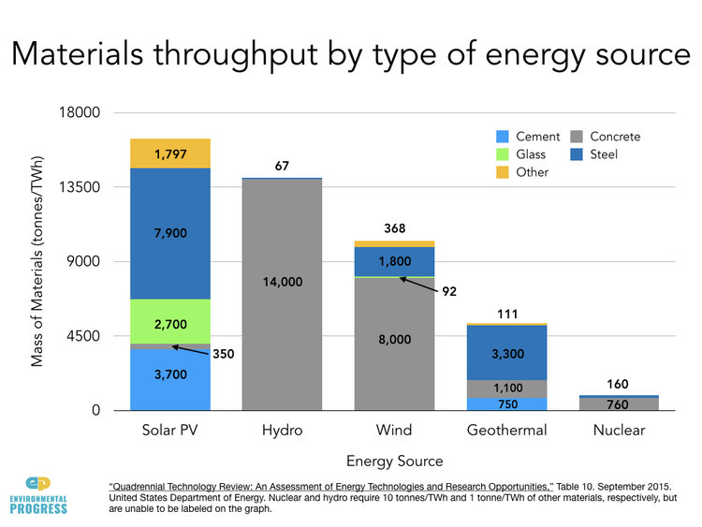
FN-17 http://environmentalprogress.org/big-news/2017/6/21/are-we-headed-for-a-solar-waste-crisis

It also turns out that wind and solar aren't just more taxing on Mother Nature. They're also more taxing on the people who extract and refine the materials that go into PV panels and wind turbines. FN And up to now, most of the material and equipment has been sourced in China, where the working conditions are far below the standards of US mines, refineries and factories:
FN https://grist.org/article/report-going-100-renewable-power-means-a-lot-of-dirty-mining/?utm_content=buffer1563c&utm_medium=social&utm_source=facebook.com&utm_campaign=buffer&fbclid=IwAR3L47LNr_hXkBDUF0105qf-3bSUzAGjrmdRaqrH4nRx2QqpnCNJqR96CEU

“With regard to the construction phase of the electricity-generating technologies, by far the largest collective dose [of radiation] to workers per unit of electricity generated was found in the solar power cycle, followed by the wind power cycle. The reason for this is that these technologies require large amounts of rare earth metals, and the mining of low-grade ore exposes workers to natural radionuclides during mining.” [emphases ours] FN 18

FN 18 http://www.unscear.org/docs/publications/2016/UNSCEAR_2016_Report-CORR.pdf See page 13, para 48.)

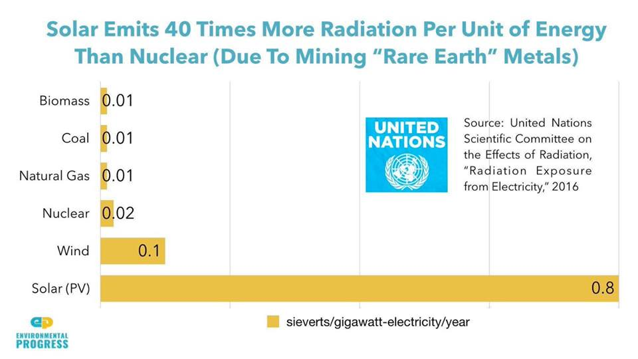

Today, nuclear power produces about 20% of US electricity, all of it carbon-free. And the mining is as safe as the "waste" stream – no one in the US has ever been injured or killed by used reactor fuel. Nuclear's contribution to national electricity would be much higher than 20%, but after Three Mile Island in 1979, the reactors that were scheduled to be built were canceled. Coal plants were built instead.

From the TMI accident until now, coal pollution emissions, although greatly improved, have hastened the deaths of nearly 100,000 Americans. FN-19 All because a misinformed public flipped out over a partial meltdown in 1979 that killed no one.
FN-19: See our earlier calculations on this, with links to source material cited:
http://www.timothymaloney.net/Preventable_Coal_Deaths_files/Coal%20death%20reduction%20-%20spreadsheet%20ref.pdf

After Fukushima, the same thing happened overseas: Both Japan and Germany drastically cut back on nuclear power. The direct result was an increase of CO₂ emissions, and premature deaths due to carbon pollution.

". . . if Japan and Germany had reduced coal instead of nuclear after Fukushima, they could have together prevented about 28,000 air pollution-induced premature deaths, and 2.6 billion tons of CO2 emissions between 2011 and 2017. Thus, these countries’ post-Fukushima energy choices have resulted in major levels of avoidable impacts of the accident."
[emphases ours]
FN 19.1
https://blogs.ei.columbia.edu/2019/06/17/post-fukushima-energy-japan-germany/?fbclid=IwAR3ymGpGpW5bUa8g5jV-RYRsKuLQFW76DnzX75A1r3esBThuC-Gz1jFyNpk

Which essentially translates to: ". . . have resulted in thousands of wrongful deaths . . . ."

This is what nuclear fear can do. This is how lethal it can be. The truth is, nuclear fear is actually far more deadly than nuclear energy or nuclear "waste".

Fear is the mind-killer.

Death print

This sobering term refers to the casualties caused per terawatt-hour of energy generation, by various energy sources. As you can see in the chart below, nuclear power has the lowest death print of any mass-energy production technology in history.

This even holds true with Chernobyl factored into the nuclear estimate, and the Banquiao dam failure taken out of the hydroelectric estimate. And if we leave out the highly-disputed 4,000 future deaths from Chernobyl (see Chapter Three), nuclear power's death print drops from 0.04 deaths per terawatt-hour, to 0.0013.

In other words, thirteen deaths for every one thousand terrawatt-hours generated. The planet's total primary energy consumption (all forms of energy) currently equates to about twenty TWh per year. At that rate, there would be one death attributed to nuclear power, somewhere in the world, about every six years.

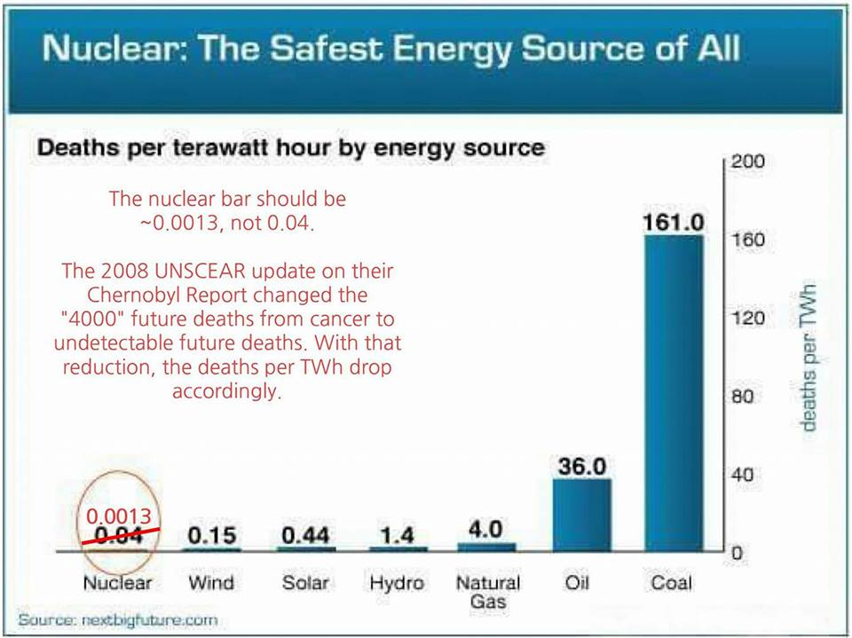
FN-20 https://www.nextbigfuture.com/2016/06/update-of-death-per-terawatt-hour-by.html

Mike - sketch a close-up comparison of nuclear's 0.0013 to wind's 0.15. It's a factor of 11.5 difference. If wind is scaled to the top of the vertical axis, present value 200, then nuclear will scale to present 17.

Even without the Banquiao disaster, hydroelectric dams have caused 2.5 times more casualties per terawatt-hour produced, than nuclear power. Wind casualties from turbine construction, installation and maintenance FN 20.5 are four times times higher than nuclear, and solar casualties are eleven times higher, mostly from rooftop workers falling to their deaths. 20.5
http://www.nacleanenergy.com/articles/32210/wind-turbine-worker-safety-the-human-factor

So it's well worth repeating:

Nuclear has the lowest death print
of any mass energy production
technology in history.

This conclusion is drawn from solid statistics, unless you're convinced that scientists and governments around the world have been suppressing the truth about nuclear power for nearly seventy years. No offense, but that's a conspiracy theory as flimsy as a chemtrail.

For those of you who aren't in the know, this anti-nuclear scare story maintains that hundreds of thousands of people (perhaps millions!) have been sickened and killed by man-made radiation – that is, from industry rather than nature.

But, the conspiracy theory goes, the actual cause of death was either ignored or delberately buried among the millions of yearly non-nuclear cancer deaths. And since one in six adults die of cancer anyway FN-21, and since radiation mortalities are impossible to distinguish from non-radiogenic cancer mortalities, the real truth remains hidden . . .
https://www.cancer.org/content/dam/cancer-org/research/cancer-facts-and-statistics/global-cancer-facts-and-figures/global-cancer-facts-and-figures-4th-edition.pdf

Hogwash. A conspiracy of this scope would require the long-term cooperation of hundreds of thousands of people working around the world before, during, and after the Cold War, and right up to the present day, with no leaks. A global nuclear deep state.

This is as preposterous as the belief that global warming studies have been deliberately faked for decades, by thousands of credentialed climate scientists working secretly in cahoots. A "watermelon" deep state – green on the outside, and commie red on the inside. Because all they really want to do is to control everyone's life . . .

Another popular anti-nuclear theory says that UNSCEAR is in the pocket of Big Nuke. It's interesting how the UN's IPCC reports (Intergovernmental Panel on Climate Change) are widely accepted, while reports from UNSCEAR (United Nations Scientific Committee on the Effects of Atomic Radiation) are rejected out of hand. Usually by the same people.

In a similar vein, there is a conspiracy theory that the WHO (World Health Organization) is controlled by the IAEA (International Atomic Energy Agency), to supposedly prevent WHO from issuing anti-nuclear reports. To the contrary, their agreement explicitly says exactly and precisely the opposite. https://rationalwiki.org/wiki/WHO-IAEA_conspiracy

Despite any theories to the contrary (conspiracy or otherwise), no deaths or cancers from radiation have been definitively linked to the production of American nuclear power, or to its stockpile of used fuel. And as it turns out, the elevated leukemia rates formerly blamed on our nuclear plants have actually been linked to chemical toxins from nearby industries, both past and present.FN-22
https://www.nature.com/news/2011/110506/full/news.2011.275.html
https://asiancorrespondent.com/2011/05/green-deaths-the-forgotten-dangers-of-solar-panels/

The cancer rates of our nuclear plant workers are on par with the general population. The same holds true for our radiology and nuclear medicine personnel. Thehe dose-rate from working full-time in a nuclear plant is the same radiation you'd get from eating five bananas per day. This is known as a Banana Equivalent Dose of five (5 BEDs). Five or more bananas a day is typical in a chimpanzee's diet, and they are not known for having elevated rates of cancer.

Bananas are rich in potassium. Most potassium (K-39) is inert, but a tiny percentage (0.012%) is radioactive K-40. So the average banana contains about 0.1 microsieverts of K-40 (1,000 microsieverts = one millisievert, or one mSv). In fact, bananas are so radioactive that a truckload can set off radiation alarms at a border crossing.

So can avocados. The average avocado has slightly less K-40, with about 0.08 microsieverts. Eating five a day of either one might give you the collywobbles, but it won't give you cancer.

This should give you a keen sense of the death-defying risks our nuclear workers are taking – day and night, rain or shine! – to provide our nation with reliable, carbon-free energy. It's truly humbling to contemplate.

